(please send to s500ijerrard@forest-oak.solihull.sch.uk or bring on MHFA training at Forest Oak.)
School:
Best Hoped for outcomes: | Data to illustrate:
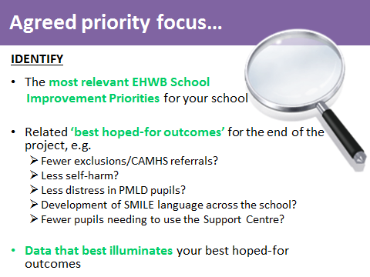
19.9.18


