Forest OAk School EXAMPLE
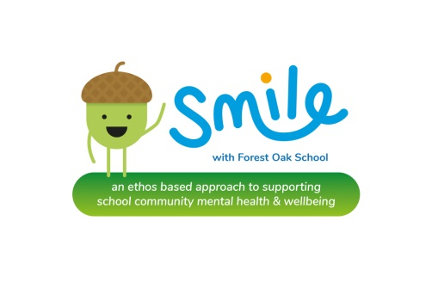
School Improvement Priorities Planning and Aims
2016-2018

SIP Planning and aims, identifying targeted activities and areas through SMILE approach.

School:  Forest Oak | Year and Targets | School Group, age phase, year or class.
School:  Forest Oak | 2016-17 | F/KS1 | KS2 | KS3 | KS4 | KS5 | Targeted children | staff | parents
Socialise | - Opportunities planned for to mix pupils across and within key stages.  - Staff’ working group to organise staff social/team building activity  - Further develop merit time and clubs activities opportunities to socialise  - Teach social skills through life-skills curriculum | *  *  * | *  *  * | *  *  * | *  *  * | *  *  * | *  * | *  *
Move  (be active) | - Daily movement for classes key stages built into day  - Eat Well Move More programme for targeted pupils  - Smart moves and/or BEAM programme used by LSAs in classes with groups | *  * | *  *  * | * | * | * | * | *
Interest  (take notice.) | - Opportunities built into all staff/pupil day for mindfulness  - Rest and Relax and/or mindfulness delivered by additional staff  - Gratitude displays and activities  - Bucket activities and programme | *  *  * | *  *  * | *  *  * | *  *  * | *  * | * | *  *  * | *
Learn  (new things) | - Provide Mindfulness training opportunities for all -staff training, parent workshops, pupil training  - Cognitive Behaviour Therapy/Anxiety awareness delivered to staff and used to support pupils/circles.  - Focused SEMH visitors/training for parents-CLDNT, MIND… |  | * | * |  |  | * | *  * | *  *
Engage  (take part and give) | - Whole school activity days-e.g. life skills/prevent/SMSC  - Community projects/charity events available for all pupils to take part in | *  * | *  * | *  * | *  * | *  * |  | *  * | *  *
Evaluation Notes:

School:  Forest Oak | Year and Targets | School Group, age phase, year or class.
School:  Forest Oak | 2017-18 | F/KS1 | KS2 | KS3 | KS4 | KS5 | Targeted children | staff | parents
Socialise | - staff social/team building activity open to interested staff  - Teach social skills through life-skills curriculum-new programme  - Parent coffee mornings and events | * | * | * | * | * |  | * | *
Move  (be active) | - Daily movement for classes – timetable- overview and monitor  - Eat Well Move More programme for targeted pupils-y9,y10  - Yoga/gym available for staff | * | * | * | * | * | * | *  * | *invited
Interest  (take notice.) | - All classes developing daily mindfulness practice-overview and monitor  - Staff developing shared resources on system  - Mindfulness and Rest and relax opportunities | *  *  * | *  *  * | *  *  * | *  *  * | *  *  * | * | *  * | *
Learn  (new things) | - Provide Mindfulness opportunities for parent workshops,  - Pupils learning mindfulness  - EP working with staff to develop SEMH practices further with individuals  - IJ groups pupils CBT, Confidence& Anxiety | *  * | *  * | *  * | *  * | *  * | *  *  * | *  * | *
Engage  (take part and give) | - Whole school activity days-e.g. life skills/prevent/SMSC  - Community projects/charity events available for all pupils to take part in | *  * | *  * | *  * | *  * | *  * |  | *  * | *  *
Evaluation Notes:

